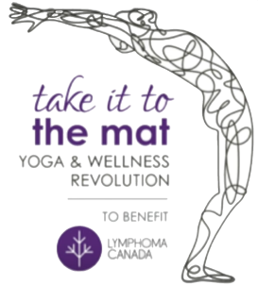

Subject Line: Former couch potato takes it to the mat for Lymphoma Canada
Yes, the rumours are all true. This (now former) couch potato has signed up to participate in take it to the mat, a yoga and wellness challenge in support of Lymphoma Canada. We all know people that have been impacted by cancer and don’t always know how to help so I’ve decided to take this challenge to help raise funds and awareness for this worthy cause.
Lymphoma Canada is Canada’s only national organization focused entirely on lymphoma. Lymphoma is the 5th most common cancer in Canada, the most common cancer in teenagers and young adults ages 15-29, the 3rd most common cancer in kids. Every 45 minutes someone is diagnosed with lymphoma. Lymphoma strikes randomly.
When I first heard about the take it to the mat, The Great Yoga & Wellness Revolution challenge, I knew this would be a great event where I can do something to help those with lymphoma and get healthy myself. I will be spending months building my yoga practice and my overall wellness towards the yoga challenge. The event in November will also host a number of experts who will be speaking on living mindfully to reduce stress and how to make better choices to inspire me to keep the wellness momentum going after the event is over.
My goal is to raise $1,000 for this campaign and I hope I can count on your support. Please click on the link provided and it will take you to my personal page where you can sponsor me. It takes a community to make a difference. Together we can do this.
Thanking you in advance for your generosity, support and encouragement.

