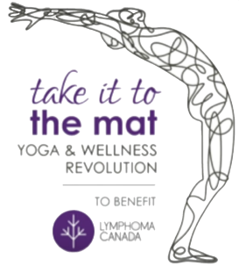

Subject Line: Support my Meditation journey to benefit Lymphoma Canada
Dear Family and Friends:
Each year I try to make a contribution to my community by actively engaging in a purposeful cause. This year I will be participating in the take it to the mat, a yoga, meditation and wellness challenge in support of Lymphoma Canada to help raise awareness and funds for this extremely worthy organization.
Lymphoma Canada is Canada’s only national organization focused entirely on lymphoma. Lymphoma is the 5th most common cancer in Canada, the most common cancer in teenagers and young adults ages 15-29, the 3rd most common cancer in kids. Every 45 minutes someone is diagnosed with lymphoma. Lymphoma strikes randomly.
take it to the mat is a full day of health and wellness awareness in support of those who are affected by lymphoma. On October 23rd, together with hundreds of other dedicated wellness enthusiasts, I will participate in a 108 minute meditation workshop.
The event will also host a number of well-known health and wellness professionals who will speak about lymphoma and provide expertise on stress reduction and mindful living to enhance well-being.

As you know, I am someone with lots of energy who needs to keep busy. Not on October 23rd; instead I will learn to become more calm, relaxed and mindful. Sounds great right, not an easy task for me, but I am up for the challenge.

Over the next few months leading up to this event, I am committed to practicing meditation regularly, in addition to yoga from time to time. During my effort to become healthier, mind and body, I will be raising money and awareness in support of lymphoma patients and their families during their difficult journey. My aim is to raise $2,000 for this campaign – and here is where you can help!

To support my campaign please click on the link provided, that will take you to my personal campaign page where you can sponsor me in this challenge.

I thank you for your generosity, your support and your encouragement. Wish me luck!

